PROJECT DOCUMENTATION
EDUGENIE – AI
AI-Powered Educational Assistant
Team ID: 2CD7E852E7294339F5C427937B6F6249
Team Leader: SIVASRI.N
Team Members: Elakkiya.B • Gopika.A • Sadhana.E • Pavithra.M

Project Overview
EduGenie is a lightweight AI-powered educational assistant built with a FastAPI backend, an HTML/CSS/JavaScript frontend, and Google Gemini API integration.

Feature | Purpose
Q&A | Answer educational questions.
Concept Explanation | Explain difficult concepts in simple language.
Quiz | Generate three-question multiple-choice quizzes.
Summarization | Create concise revision summaries.
Learning Path | Provide a beginner-to-advanced learning plan.

Team

Member | Role
SIVASRI.N | Team Leader & Lead Developer
ELAKKIYA.B | Developer
GOPIKA.A | Video Editing & Voice Over
SADHANA.E | Video Editing
PAVITHRA.M | Documentation

Objectives and Use Cases
- Build a complete browser-based educational AI assistant.
- Integrate Gemini through the Google GenAI Python SDK.
- Expose separate FastAPI endpoints for each learning feature.
- Validate user input and AI-generated quiz structure.
- Provide a simple responsive interface that works locally in a browser.

Main Use Cases
- Ask an academic question and receive a concise answer.
- Enter a concept such as Pythagoras theorem for a beginner-friendly explanation.
- Generate three MCQs with four options each from educational text.
- Summarize a long passage for quick revision.
- Request a structured learning path for a topic such as SQL.
Technology Stack
Technology | Purpose | Project Use
Python 3.10+ | Application development | Backend
FastAPI | REST API | main.py
Uvicorn | ASGI local server | uvicorn main:app --reload
Jinja2 | HTML template rendering | templates/index.html
HTML/CSS/JavaScript | Browser interface | templates + static
Google GenAI SDK | Gemini integration | gemini_client.py
Pydantic | Request validation | schemas.py
python-dotenv | Environment variables | .env
Transformers + PyTorch | Optional local explainer | requirements-local.py

The project uses a modular structure so individual learning features can be developed and tested independently.

Project Structure
The original project structure screenshot is retained below without changing the image content.
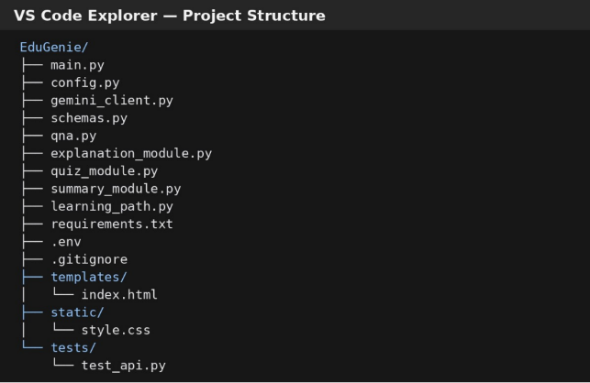
Fig. 1: VS Code project structure

System Architecture
EduGenie follows a browser → FastAPI → feature module → Gemini API → formatted response pattern.
- Browser UI
- JavaScript task selection and request
- FastAPI endpoint
- Input validation
- Feature module: Q&A / Explain / Quiz / Summary / Learning Path
- Gemini service
- Response validation and formatting
- Browser displays the result
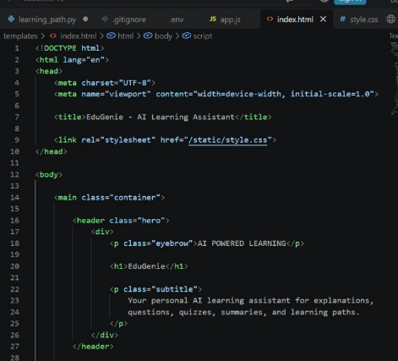
Fig. 2: Frontend implementation section from the original project

Prerequisites and Installation
- Python 3.10 or newer
- VS Code (recommended)
- Google AI Studio Gemini API key
- Internet access for Gemini API calls

Installation Commands
python -m venv .venv .\.venv\Scripts\Activate.ps1 python -m pip install --upgrade pip pip install -r requirements.txt

Environment Configuration
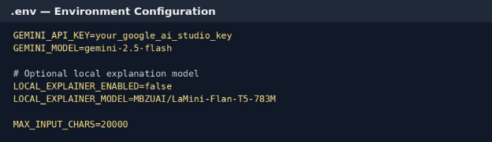
Fig. 3: Original .env configuration screenshot

Milestone 1 – Model Selection and Configuration
The implementation centralizes model configuration in config.py. The Gemini model is read from GEMINI_MODEL, while the optional local explainer is controlled through the project configuration.
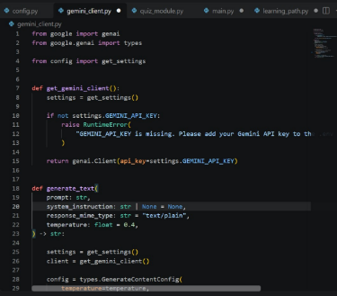
Fig. 4: Original Gemini client configuration
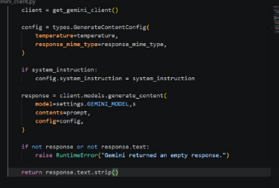
Fig. 5: Original content-generation configuration

Milestone 2 – Backend and Core Functionalities
The FastAPI backend exposes routes for the five educational features. Requests are validated and passed to the corresponding feature module.
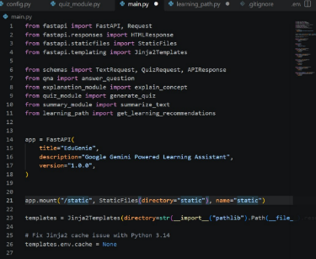
Fig. 6: Original main.py backend section
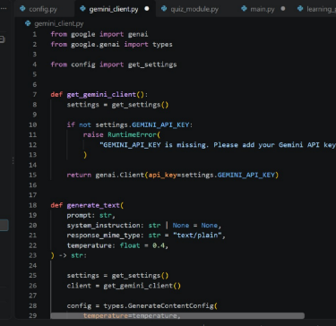
Fig. 7: Original Gemini client section

Backend Validation and Quiz Handling
The project validates quiz structure so that each generated question has the expected fields and four options.
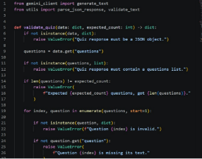
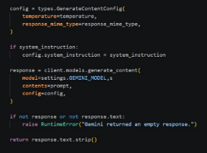

Fig. 8: Generation configuration
Fig. 9: Quiz validation logic

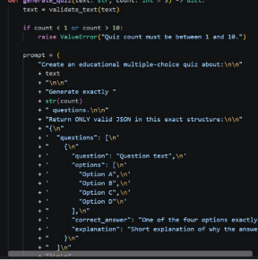
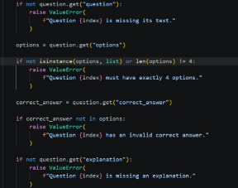

Fig. 11: Quiz JSON structure
Fig. 10: Quiz validation

Summary and Explanation Modules
The project includes a Gemini-based explanation flow and a summarization module designed for simple, educational responses.
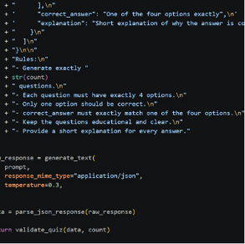
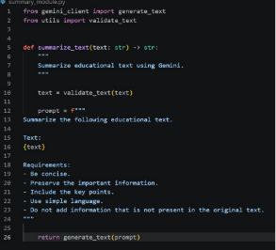
Fig. 13: Summary module
Fig. 12: Quiz response structure

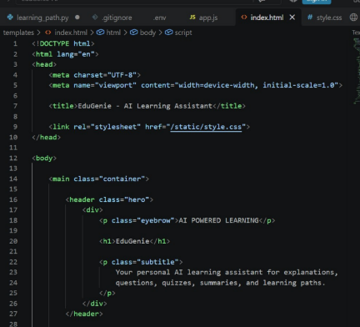
Fig. 14: Original frontend implementation code

Frontend Development
The frontend is a responsive single-page interface. Users select a task, enter a question or topic, and the JavaScript code sends a POST request to the matching FastAPI endpoint.
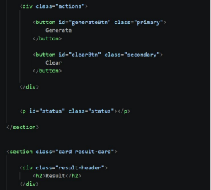

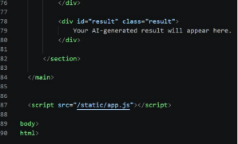

. 15: Task controls

Running the Application
The documented local run sequence is:
- Open the EduGenie folder in VS Code.
- Create and activate the .venv virtual environment.
- Install dependencies with pip install -r requirements.txt.
- Create .env and enter the Gemini API key.
- Start the application with uvicorn main:app --reload.
- Open http://127.0.0.1:8000 in a browser.
- Open /docs for interactive API documentation.

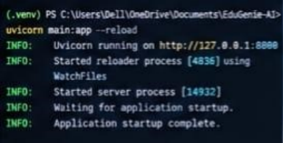
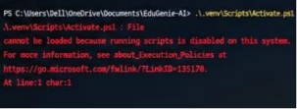

Fig. 17: PowerShell activation output Fig. 18: Uvicorn running output

7.1 Configuration code
Code Section: config.py

import os
from functools import lru_cache

from dotenv import load_dotenv

load_dotenv()

class Settings:
GEMINI_API_KEY: str = os.getenv("GEMINI_API_KEY", "")
GEMINI_MODEL: str = os.getenv(
"GEMINI_MODEL",
"gemini-2.5-flash"
)

EXPLANATION_PROVIDER: str = os.getenv(
"EXPLANATION_PROVIDER",

"gemini"
)

LOCAL_EXPLANATION_MODEL: str = os.getenv(
"LOCAL_EXPLANATION_MODEL",
"MBZUAI/LaMini-Flan-T5-783M"
)

APP_NAME: str = os.getenv(
"APP_NAME",
"EduGenie"
)

MAX_INPUT_CHARS: int = int(
os.getenv("MAX_INPUT_CHARS", "30000")
)

HOST: str = os.getenv(
"HOST",
"127.0.0.1"
)

PORT: int = int(
os.getenv("PORT", "8000")
)

@lru_cache
def get_settings() -> Settings:
return Settings()

CODE SECTION: MAIN.PY

from fastapi import FastAPI, Request
from fastapi.responses import HTMLResponse
from fastapi.staticfiles import StaticFiles
from fastapi.templating import Jinja2Templates

from schemas import TextRequest, QuizRequest, APIResponse
from qna import answer_question
from explanation_module import explain_concept
from quiz_module import generate_quiz
from summary_module import summarize_text
from learning_path import get_learning_recommendations

app = FastAPI(
title="EduGenie",
description="Google Gemini Powered Learning Assistant",
version="1.0.0",
)

app.mount("/static", StaticFiles(directory="static"), name="static")

templates = Jinja2Templates(directory=str(__import__("pathlib").Path(__file__).resolve().parent / "templates"))

# Fix Jinja2 cache issue with Python 3.14
templates.env.cache = None

@app.get("/", response_class=HTMLResponse)
async def home(request: Request):
return templates.TemplateResponse(
request,
"index.html"
)

@app.get("/health")
async def health():
return {
"status": "ok",
"application": "EduGenie"
}

@app.post("/qa", response_model=APIResponse)
async def qa(request: TextRequest):
result = answer_question(request.text)
return APIResponse(
success=True,
result=result
)

@app.post("/explain", response_model=APIResponse)
async def explain(request: TextRequest):
result = explain_concept(request.text)
return APIResponse(
success=True,
result=result
)

@app.post("/quiz", response_model=APIResponse)
async def quiz(request: QuizRequest):
result = generate_quiz(
request.text,
request.count
)
return APIResponse(
success=True,
result=result
)

CODE SECTION: qna.py
from google import genai
from google.genai import types

from config import get_settings

def get_gemini_client():
settings = get_settings()

if not settings.GEMINI_API_KEY:
raise RuntimeError(
"GEMINI_API_KEY is missing. Please add your Gemini API key to the .env file."
)

return genai.Client(api_key=settings.GEMINI_API_KEY)

def generate_text(
prompt: str,
system_instruction: str | None = None,
response_mime_type: str = "text/plain",
temperature: float = 0.4,
) -> str:

settings = get_settings()
client = get_gemini_client()

config = types.GenerateContentConfig(
temperature=temperature,
response_mime_type=response_mime_type,
)

if system_instruction:
config.system_instruction = system_instruction

response = client.models.generate_content(
model=settings.GEMINI_MODEL,s
contents=prompt,
config=config,
)

if not response or not response.text:
raise RuntimeError("Gemini returned an empty response.")

return response.text.strip()

Application Output – EduGenie Interface
The following are the actual project interface/output screenshots supplied in the original documentation.
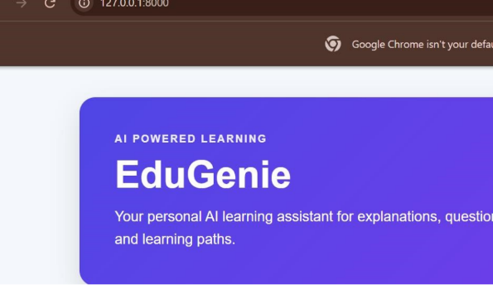
Fig. 19: EduGenie home interface

Output User Input and Task Screen
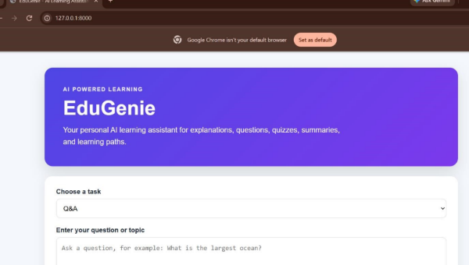
Fig. 20: EduGenie task interface
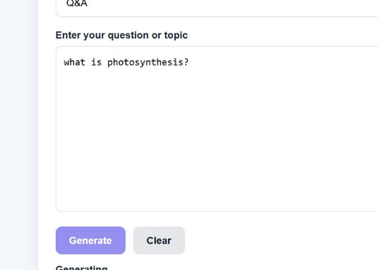
Fig. 21: User question/topic input

Output Generated Results
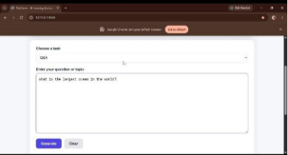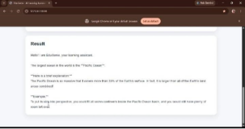
Fig. 22: Task input screen Fig. 23: Generated result

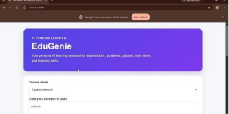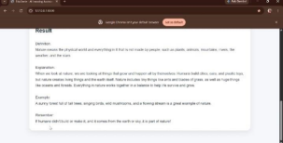
Fig. 24: EduGenie interface Fig. 25: Generated educational response

Output Learning Features
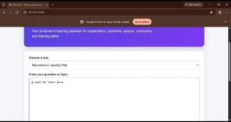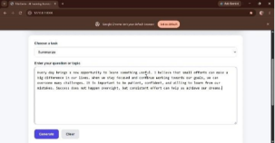
Fig. 26: Learning task screen Fig. 27: Learning-path/result screen

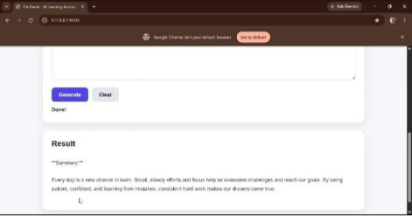
Fig. 28: Final project output screen

Functional Testing, Security and Future Enhancements

Feature | Example Test | Expected Result
Q&A | What is the largest ocean? | Educational answer returned
Explain | Photosynthesis / Pythagoras theorem | Simplified explanation
Quiz | Pythagoras theorem passage | Three questions, four options each
Summarize | Photosynthesis paragraph | Concise revision summary
Learning Path | I want to learn SQL | Beginner-to-advanced learning plan

Security
- Keep GEMINI_API_KEY in .env and never place it in browser JavaScript.
- Do not commit .env to GitHub.
- Use HTTPS, authentication, rate limiting, and stronger production validation before public deployment.

Future Enhancements
- Progress tracking and learner dashboards
- Multilingual support
- Voice input and output
- Image and PDF learning support
- Authentication and learner profiles
- Interactive quizzes and cloud deployment
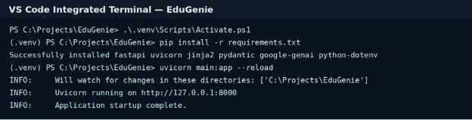
Fig. 29: Original VS Code terminal/project output
Conclusion:
EduGenie is implemented as a functional local AI learning assistant with a FastAPI backend, responsive browser frontend, centralized Gemini integration, validation, and five core educational features.

